Brief instructions on how to use the desireland forum
To view the latest topics – click on Show new topics since last visit

To view a topic, click on the topic name within the forum e.g. ‘Welcome’ in this example.
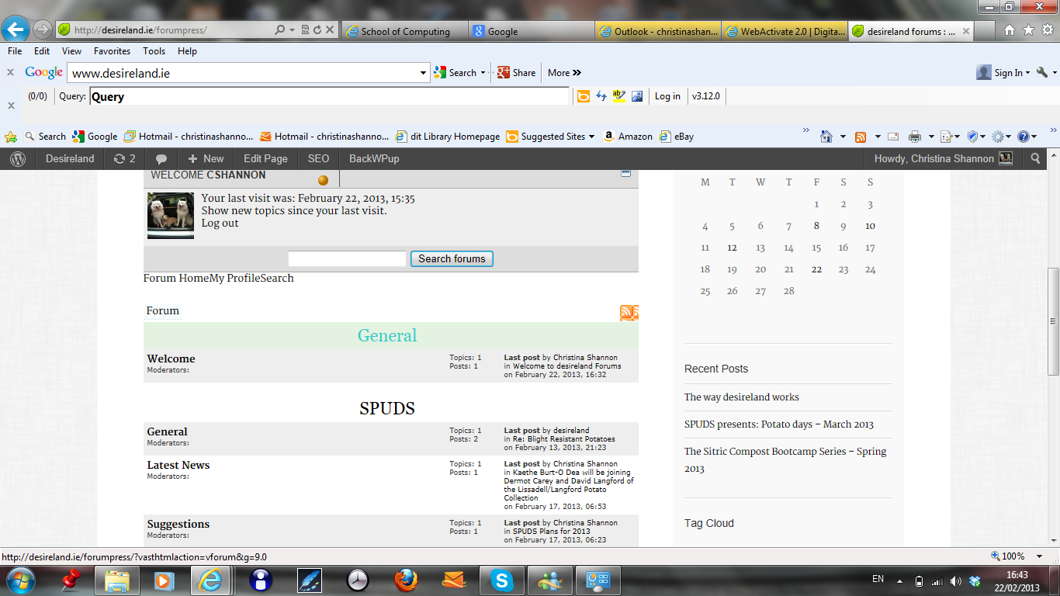

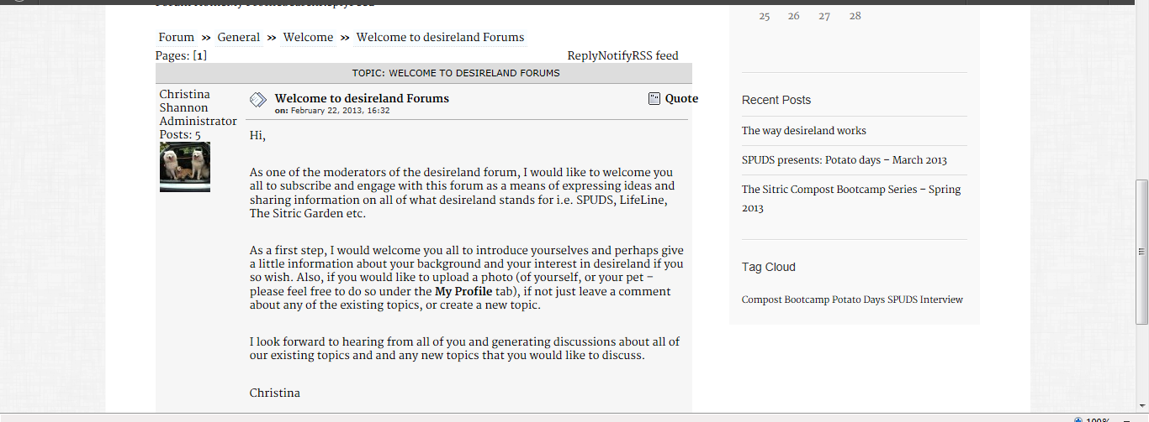

Click Notify – if you want to be notified by email when a reply is posted to this topic

Click Reply – to reply to a topic
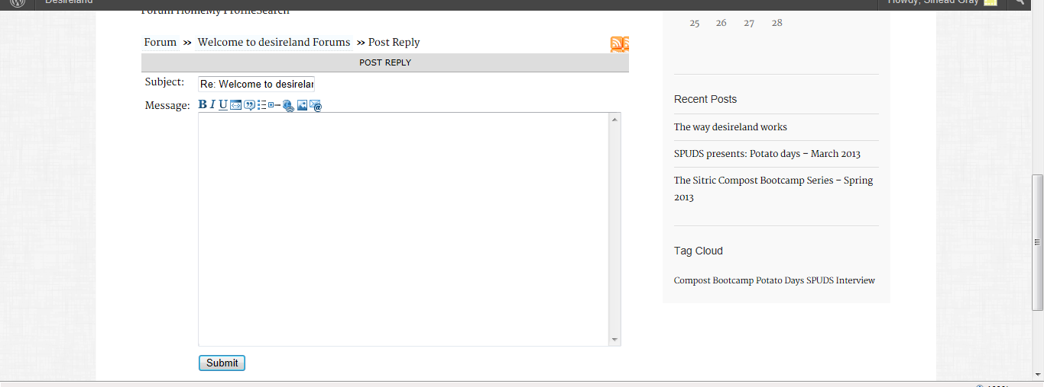
You must be logged in to post a new topic.
There is a login button in the footer of this site, please login with the username and password that has been issued to you via your email.
To post a new topic – click into the category name, then the forum name e.g. General>Welcome or SPUDS>General and click New Topic, enter your subject, then your message, then click submit.
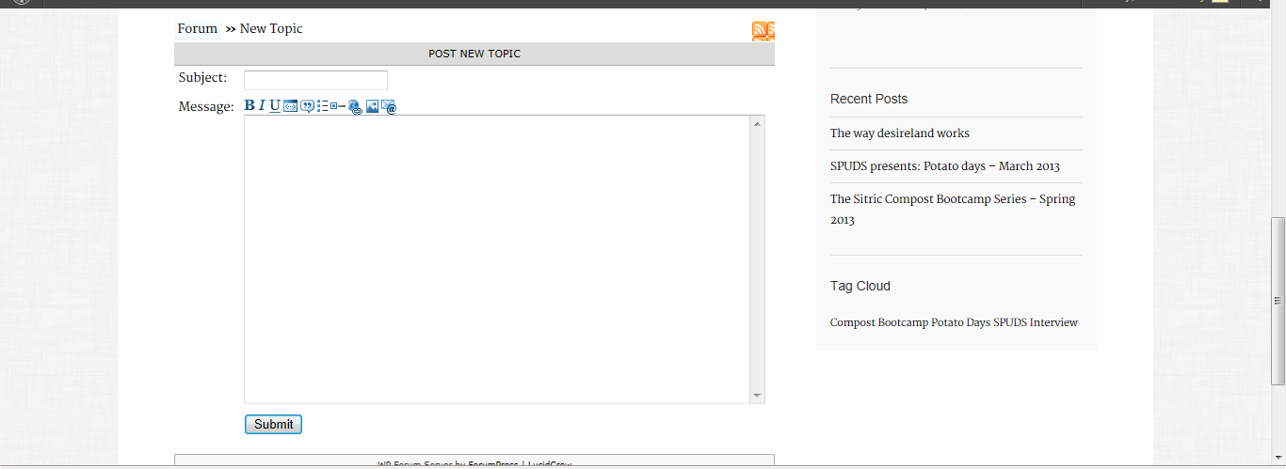

If you want to update your profile information or upload a photograph of yourself click on MyProfile, and click edit personal options, click on edit forum options to see your forum options
